# Problem 5 – Half Byte Swapper

**Example**

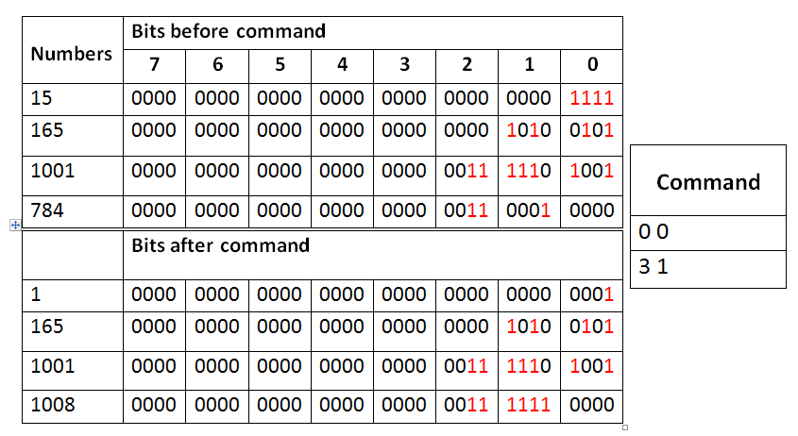You are given **four 32 bit integer** numbers. Your task is to **swap groups of 4 bits** **between** the 4 numbers. You will be given **series of commands**. Commands end when the last command given is **"End"**. Each command consists of **2 lines** each holding **2 numbers** separated **by space**. The first number in the command shows which number **(0 -3)** will be manipulated and the second number which group **(0-7)** of 4 bits will be swapped. The 2 lines in each command show the 2 numbers that will swap groups of 4 bits. Print the four numbers after all commands have been executed.   
See the examples on the right to understand you task better.

## Input

Input data is read from the console.

* On the first **4 lines** you will be given **4 32 bit integer** numbers
* On each of the **next 2 lines** will be a single command showing the 2 numbers and groups that will swap bits.
* On the last line on the input will be given the command "End" indicting no more commands will be given

The input data will always be valid and in the format described. There is no need to check it explicitly.

## Output

The output data must be printed on the console.

* Print the 4 input numbers on separate line after all commands are executed

## Constraints

* The 4 input numbers will be in the range [0... 4, 294,967,295].
* The first number in the command will be between [0-3] and the second between [0-7]
* Time limit: 0.25 seconds. Allowed memory: 16 MB.

## Examples

|  |  |  |  |  |  |  |  |  |  |  |
| --- | --- | --- | --- | --- | --- | --- | --- | --- | --- | --- |
| **Input** | **Output** |  | **Input** | **Output** |  | **Input** | **Output** |  | **Input** | **Output** |
| 15  165  1001  784  0 0  3 1  End | 1  165  1001  1008 | 165  37584  53  2345  1 3  3 5  1 1  1 4  End | 165  852480  53  9439529 |  | 15  983040  15728640  251658240  1 4  1 0  2 5  2 0  3 6  3 0  End | 15  15  15  15 |  | 0  327680  1792  262144  1 4  0 1  2 2  0 0  3 4  0 2  End | 1111  0  0  0 |